# [**‘Law & Order: SVU’ Showrunner: Season 24 Will Be About Olivia Benson’s ‘Healing and Deep Trauma’**](https://www.thewrap.com/law-order-svu-showrunner-season-23-preview-olivia-benson/)

David Graziano and executive producer Julie Martin also discuss Rollins’ (Kelli Giddish) storyline and relationships in her final season

**Sharon Knolle** | September 10, 2022 @ 1:15 PM

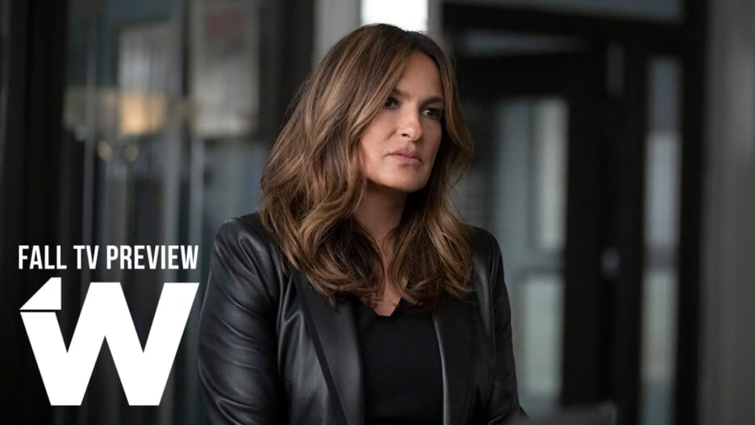

*"Law & Order: SVU" (NBC)*

David Graziano, who takes over showrunning duties on “Law & Order: SVU” from longtime executive producer Warren Leight, told TheWrap that Season 24 will be all about “healing and deep trauma” for Captain Olivia Benson (Mariska Hargitay), who’s been put through the wringer over the last two decades on the NBC show.

Graziano is thrilled to be working with Hargitay, who agreed it was time to deal with Benson’s considerable losses over the years. He’s also glad to be reunited with Octavio Pisano — Graziano gave the actor who joined “SVU” last season as Detective Joe Velasco his first big break on the show “Coyote.”

TheWrap spoke to Graziano and fellow executive producer Julie Martin ahead of the Season 24 premiere on September 22 as part of our Fall TV Preview. (*Note: This interview was conducted before the news Kelli Giddish will depart at the end of the upcoming season.*)

**TheWrap:** You both co-wrote Episode 2, the one that follows the big crossover.

**David Graziano:** ‘The One You Feed’ starts our season off with a bang. There’s a case that comes up, a grisly, high profile case, a subway attack of a tourist family. And there’s a gang behind it. So it brings Benson into conflict with a rival captain on the gang unit, and he thinks it’s a gang case from his estimation, and he doesn’t know anything about sex crimes, doesn’t care to view it as a sex crime. But for Benson, of course, the element of the crime that takes most prominence is the fact that it’s a sex crime. So it allows Mariska to go toe-to-toe with a very formidable actor by the name of Maurice Compte. They’re just great together.

And we also introduce a young actress named Molly Burnett, playing this detective Grace Muncie. She’ll be a recurring on our show and she’s just really interesting to watch, riveting. There are some great scenes between her and Mariska. And then you see her more in Episode 3 and Benson really takes her under her wing.

**What is Benson’s arc for this season?**

**Julie Martin:** What we’re trying to explore this year is Benson has been through a lot of trauma over the 23 years. It’s time to really explore that trauma, do a deep dive into that and figure out how to move through it and how to get past it rather than just live in the trauma. So that informs a lot of the storytelling. Obviously all SVU cases involve a level of trauma. But she’s looking at it in a different way, getting healing for survivors, getting justice for survivors, was paramount, and we hope to add an additional element of healing from trauma and a long term way to a lot of these cases through Benson’s experiences.

**Will we see more crossovers with Chris Meloni?**

**Graziano:** We’re trying to figure that out. But logistically, it’s tough because he’s in every scene of ‘O.C.’ and it’s very hard. We can’t just borrow him without really messing up their production schedule.

**Martin:** Even if we don’t see him in person on our screen, he remains very much a character as far as Benson and the squad goes and there will be discussions about him. And she’ll, especially in our first episode, there’s a little back and forth between her and this new character Duarte, and Stabler’s name comes up.

**Graziano:** He calls her on the fact that maybe she’s reacting to him the way she is because he reminds her of Stabler a little bit. There’s a little projection going on for Captain Benson.

**Martin:** I think their relationship is an essential part of the show. And we don’t shy away from it even if we don’t have as much availability to have them on screen together as the fans would like.

**Graziano**: I’m a hopeless romantic. I believe true love prevails. Hopefully, one day, in the distant future, we don’t want to open ourselves up to the ‘Moonlighting’ curse. But you know, that in the end, after they both defeat the monsters hiding under their bed and are ready and able to have a healthy relationship, that’s there for them.

**So you’re thinking, maybe in the series finale, they walk off into the sunset together?**

**Graziano:** Season 53! *(Laughs)*

**Martin:** We know Stabler has been through an incredible amount of trauma also with his wife being killed and his adjusting to this new position where he is [at] NYPD and we just want to show both of them going through that process and that Benson has her own trauma to deal with. Maybe rushing into a relationship right now isn’t the best thing for either one of them.

**Graziano:** There’s a lot of complexities there and a lot of things that need to be resolved before she’s even ready for anything approaching relationships.

**Last season she thought maybe it was time to retire. Is that still on her mind?**

**Graziano:** No. She’s moving into a new phase of her career. She’s absorbed a lot of trauma, not just her own just, but [from] other people. What must it be like to go to work every day and see the darkest parts of humanity [evident] in front of you and have to confront that? We had lunch with Mariska early on before the season even started and talked about what we thought the season was gonna be about. Like Julie said before, healing and deep trauma was a major, major thing that we all could get behind.

**And Octavio Pisano is back?**

**Graziano:** Yes. I love Octavio. I auditioned him on ‘Coyote’ and he was working as a busboy in some restaurant in San Diego. He took what I think is one of the hardest monologues I’ve written for an actor for an audition. And Octavio made me forget that I wrote it. I felt like somebody on a barstool was telling me a story. He’s a great actor and he’s gonna be a prominent part of the season. Peter (Jankowski) and Dick (Wolf) really just loved him, you know, and he’s very magnetic on screen. He’s got a wolfish kind of charm, [and he’s a] handsome rogue. I saw something in him which is pretty hard to miss. You’d have to be blind. And they’re the ones that put them on the show. I’m in good company with respect to casting taste.

**What can you tell us about Rollins’ storyline?**

**Martin:** The most exciting thing for us is that Rollins and Carisi, or #Rollisi, are moving forward and are going strong. They’ll have some challenges along the way as every relationship does. But I think they’re going to learn from each other and figure out how to move past those and the actors are excited about it and we’re excited too.

**Graziano:** Our story is going to be a story of triumph, triumph of the human spirit. I’m a huge Rollisi shipper. I love them together. I just love their humble origins and watching two working class kids find happiness in the world is super important to me as a former working class kid.

**Martin:** And there’ll be a lot of growth between Benson and Rollins too. I mean, it’s gone, obviously from their beginnings when they weren’t and now they’re the best of friends. They’ve grown so much closer over the years and we’re finding more ways to explore that relationship and how to take their relationship deeper and have them talk about what each other’s going through and that’s been great to write.

**Graziano:** Those are some of the most fun scenes Julie and I have had writing one or two of them. Actually, I’d be lying if I said one or two of them didn’t elicit a high-five, just between the two of us.

*“SVU” returns Sept. 22 at 9 p.m. ET/PT on NBC.*